Team 1 Project

Across Year 2012 to 2016

* **Age Group :**
* National wide : age bracket of 55-59 has highest mental health issue. In contrast , the selected states of NY and NJ our finding shows that the highest mental health issue falls between 60-64 while the number of affected citizen are 59% and 36% in each of this state respectively.
* Exception: In 2013, the age bracket in NJ, moved up to 65 to 69.

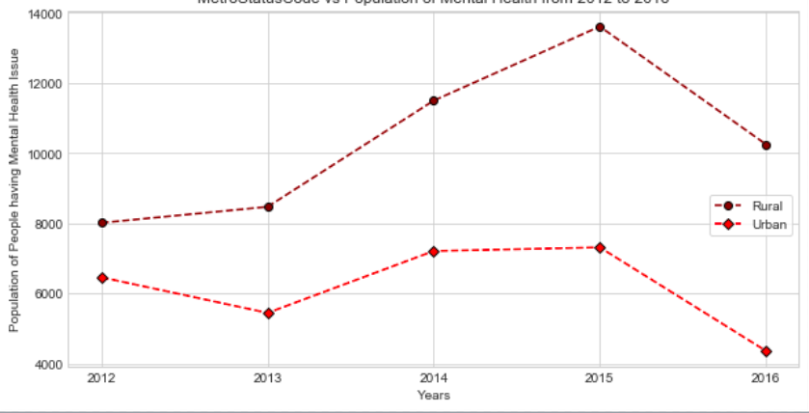

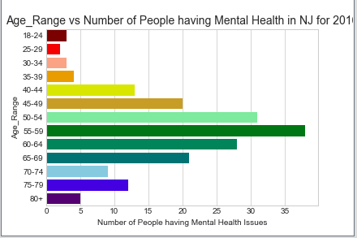

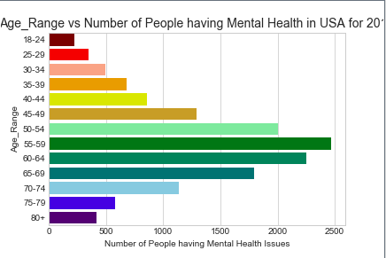

* **Employment Status**:
* The data skewed slightly towards the unemployed population, having the highest mental health based on these factors:

1. Population of mentally retarded citizens are easy to gather due to government funding
2. Department of Labor statistics indicated that most unemployed citizen ran into mental health issue during economic meltdown spanning between 2008 to Q1 of 2016.

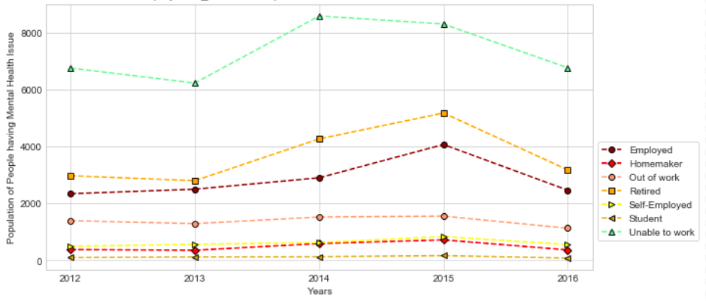

* Gender:
* Both the National and State data indicated that the Male had the highest population in mental health issues.

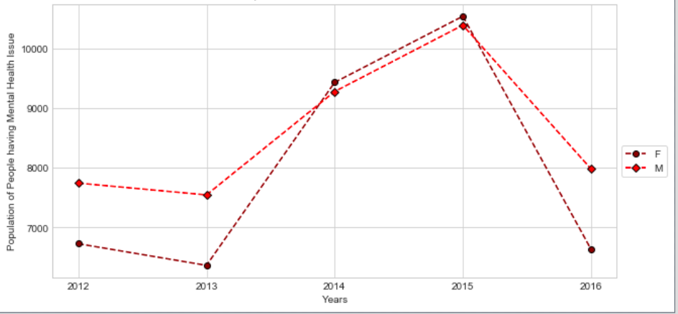

* Race:
* The White race took a dominant position in the mental health issue both national and two states selected for our findings.

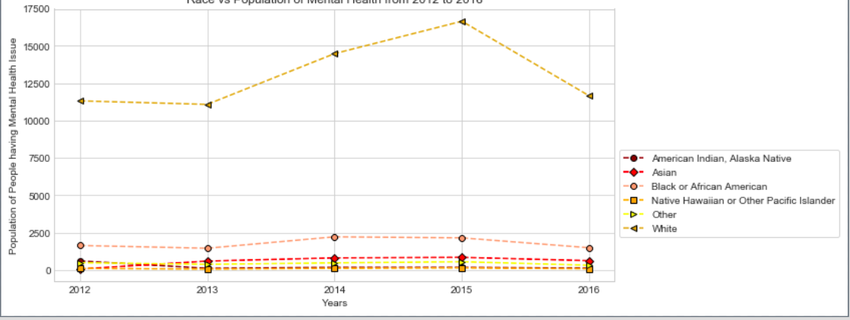

* Urban and Rural:
* National statistics indicate that mental health issue are predominant in Rural that the Urban cities, while in the state of NJ, our data shows that most of the health issue are in Urban cities.

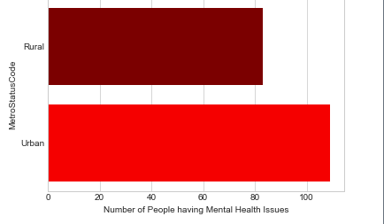

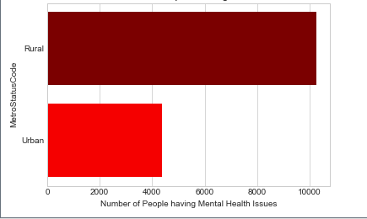

* Health Coverage:
* All mental heath issues are covered under government funding through Medicaid and Medicare program monitored by Center for Medicaid and Medicare(CMC)